CRADLE MOON CONSERVANCY | Bush Series #1 |

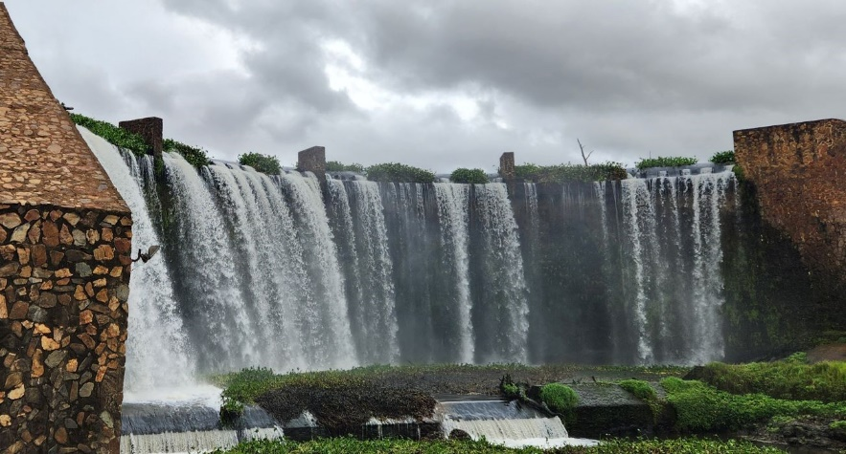





CATEGORIES club members non-club
Senior (21+) R160 R180
Juniors/Students R120 R140
Group (Max. 2) R200 R220
Add group runners +R70 each
Entry fee includes access and activity fees
Emit Card Hire +R25
ALL SPECTATORS/NON-COMPETITORS must purchase an exit wrist band from the activity centre before they leave.
WHERE
Cradle Moon Conservancy (Muldersdrift)
GPS: S25º57.739’ E27º 51.559’
What Three Words: scoffed.luckier.crinkled
Through security, follow signs to Cradle Moon and Lakeside Lodge.

WHEN
Sunday 5th May 2024
Registration 08:00 – 09:30
Starts 08:30 – 10:00
Courses close 12:00

STRICTLY PRE-ENTRY ONLY
Entries close midnight Wednesday 1st May
www.ORIENTER.CO.ZA
Participants take part in this event at their own risk and indemnify the organisers, the RACO club its members and volunteers from any claim arising at, during, around or as a result of this orienteering event. On registration at the event and on payment of your entry fee, you hereby accept that you have read and understood this notice and agree to abide by the terms set out herein.*There are wild animals in the Conservancy (including giraffe, hippo, rhino and antelope). Do not approach any animal – give them space!
NB. Competitors’ wrist bands (Exit Permit) – WILL BE ISSUED AT REGISTRATION and TO BE WORN WHEN COMPETING. ALSO REQUIRED WHEN LEAVING AT MAIN SECURITY GATE!! Spectators remember to buy at the activity centre before leaving.

CONTACT ME FOR MORE INFO
Hilton Schipholt (Planner) / 0824116744 / hilton@lejn.co.za Gary de Klerk (Controller) / 0822933353 / gdeklerk1@gmail.com www.racorienteers.co.za

TECHNICAL STUFF
Courses:
Yellow [1km] Accompanied children (R20)
Orange [2km] Tech 2; Phys 1
Light Green [3km] Tech 3; Phys 2
Green [5km] Tech 4; Phys 3
Blue [7,5km] Tech 4; Phys 4
Brown [8,5km] Tech 4; Phys 4
Starts will be at 3 minute intervals per course
Terrain: Open grassland, bushveld, wooded areas, relatively flat with some rocky outcrops
Map: Scale 1:10,000 / 5m Contours map on A4. Survey/cartography by Pat de Klerk 2020/partially updated Apr 2024

