ST ALBAN’S COLLEGE | Urban Series #9




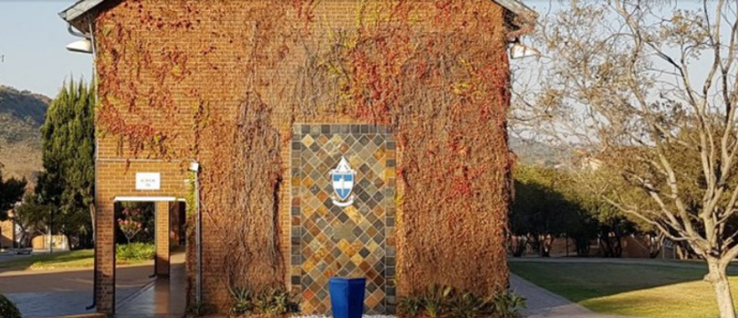


Participants take part in this event at their own risk and indemnify the landowners, organisers, the RACO club, its members and volunteers from any claim arising at, during, around or as a result of this orienteering event. On registration at the event and on payment of your entry fee, you hereby accept that you have read and understood this notice and agree to abide by the terms set out herein.
WHERE
St Alban’s College
(110 Clearwater Road,
Lynnwood Glen, Pretoria):
From the N1 north, exit at Atterbury Rd.
Turn right toward Menlyn Shopping Centre and left into the Lois Ave slipway.
At the circle turn right into Ingersol, and at the T-juntion turn left into Glenwood Road.
At the circle turn right into Clearwater Rd. Continue to the main entrance on your right and report to security. Within the school follow the signs to parking.
What Three Words: spirit.seaweed.heavy
TECHNICAL STUFF
Courses:
Explorer ±2,0km
Women ±3,0km
Men ±3,5km
Starts will be at 1 minute intervals.
Emit will be used.
Terrain : School grounds and buildings
Map : Scale 1:3000 / 2m contours map on A4. Cartography by Nico van Hoepen, September 2023.

CATEGORIES
Club Non-Club Senior (21+) R120 R140
Juniors/Students R90 R110
Group (Max. 4) R150 R170
Emit Hire +R15 +R15
PRE-ENTRY ONLY AT
www.orienter.co.za
Entries close 11 October 2023
Entry fees payable on entry
CONTACT ME FOR MORE INFO
Nico van Hoepen | 082 300 0386 nico.vanhoepen@gmail.com www.racorienteers.co.za

WHEN
Sunday 15 October 2023
Registration 8:30 – 9:00
Starts 9:00 – 10:00
Prize-Giving 11:30

